**Experiment No :- 07**

***Title :- Study and implementation of scheduling and tracking of the project. Prepare a project scheduling using WBS Gannt Chart for Jira.***

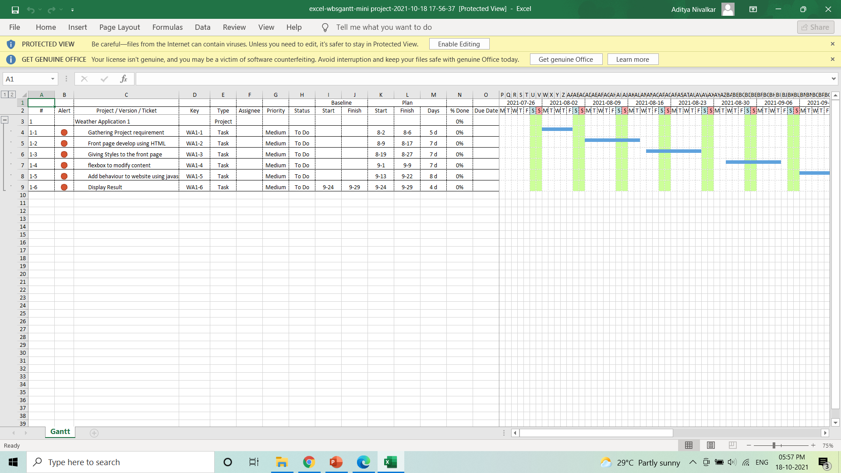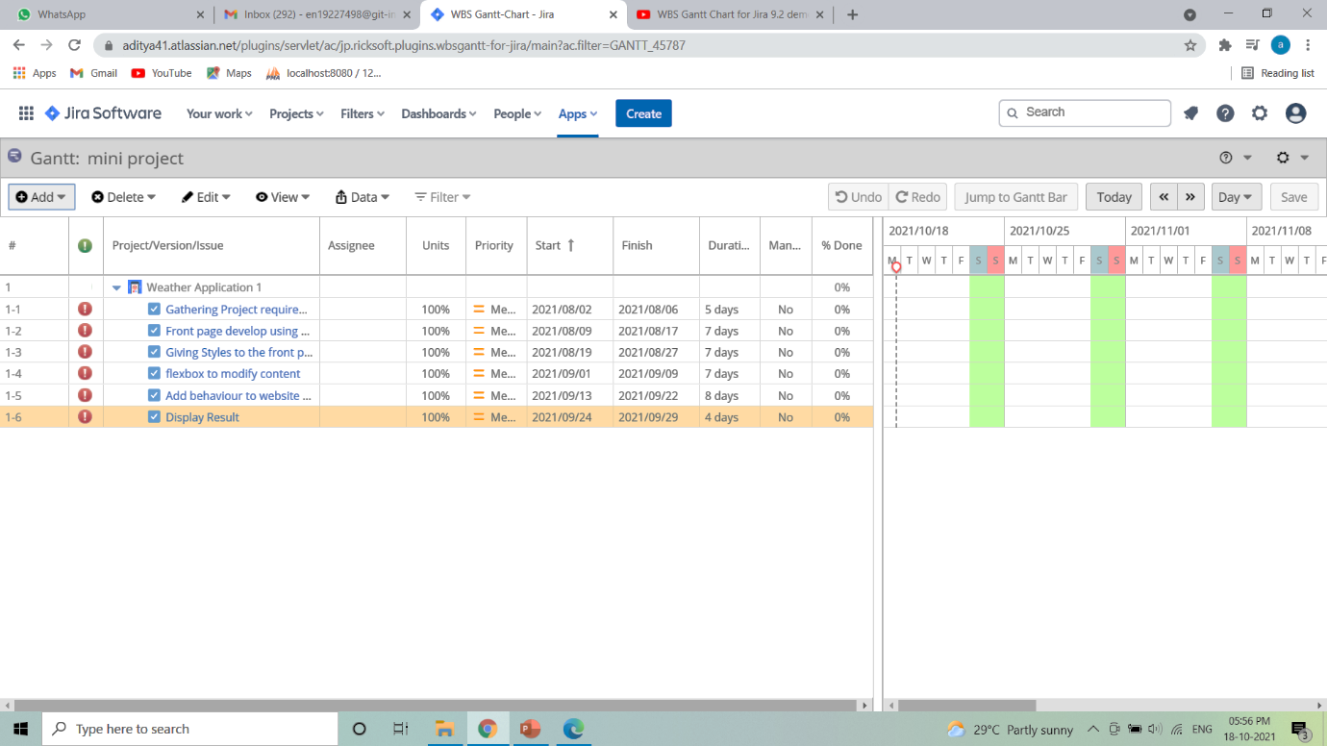**Output :**